http://discrete.gr/complexity/

Amortized Analysis
“averaged” expense of an operation
worst case of operation can be too pessimistic

//7 Functions//
Constant = f(n) = c

Logarithm = for programmers, logn = log₂n...use base 2 because computers store ints in binary and a common op in many algorithms is to repeatedly divide an input in half.

Linear = f(n) = n…….have to do an operation for each of n elements

N Log N = f(n) = n log n

Quadratic = f(n) = n2…….nested loop

Cubic = f(n) = n³

Exponential = f(n) = b^{n}…..where b is a positive constant (base) and n is the exponent

/* Theta N – Big Theta*/
after counting the number of instructions, the upper AND lower bound.

any program that is Θ( a ) is O( b ) when b is worse than a.

/* OMEGA N */
lower bound, best case analysis (i.e. we've improved our program and made it perform less instructions) Ω

/* Big O Notation */
measures how well an algorithm scales as the amount of data involved increases. Upper bound, the worst case analysis.

Algorithm consumes more memory = space complexity
algorithm takes more time = time complexity

Asymptotic behavior = dropping all factors and keeping the largest growing term
f( n ) = 5n + 12 gives f( n ) = n.
f( n ) = 109 gives f( n ) = 1.
f( n ) = n² + 3n + 112 gives f( n ) = n²
f( n ) = n³ + 1999n + 1337 gives f( n ) = n³
f( n ) = n + sqrt( n ) gives f( n ) = n

//ETC
A Θ( n ) algorithm for which we found an O( 2n ) upper bound.

This may seem like a bound that is not tight, but this is not actually true. This bound is in fact tight. Recall that the asymptotic behavior of 2n and n are the same, and that O and Θ are only concerned with asymptotic behavior. So we have that O( 2n ) = O( n ) and therefore this bound is tight as the complexity is the same as the Θ.

//BIG OMEGA / SMALL OMEGA
So Ω gives us a lower bound for the complexity of our algorithm. Similarly to ο, we can write ω if we know that our bound isn't tight. For example, a Θ( n3 ) algorithm is ο( n4 ) and ω( n2 ). Ω( n ) is pronounced "big omega of n", while ω( n ) is pronounced "small omega of n".

/* LOGARITHM */
the inverse operation of exponentiating something

/* SQUARE ROOTS */
the inverse operation of squaring something

2(x) = 1024
2¹⁰

https://roadmap.sh/guides/big-o-notation

/* Array */
Objects with the same types in an array

INDEX = number associated with that place in the array(0 based)

INSERTION = difficult if putting an item in the middle. Have to move everything after that spot by one. In the worst case this takes O(n) aka linear time

DELETION = causes an empty box, might have to move everything by one again

/* Binary Search aka half-interval search */
Sorted array, want to see if a number exists in the array. Start in the middle, is my num bigger or smaller? Get rid of the bigger or smaller half or if you find it, stop!

EFFICIENCY = O(log(n)) ......always dividing the array by 2 (in the worst case)...last iteration is 1 = n / 2^{i} aka 2^{i} = n aka i = log( n )

/* Bubble sort */
O(n²) eff sorting algorithm that "bubbles" up the last highly sorted item on each iteration

EFFICIENCY = O(n²)

/* Selection Sort */
In-place comparison sort. Divide the array into a sorted L/R increasing, empty array and the unsorted, (at start) full array. Find the smallest item in the unsorted list, exchange it so it goes into the sorted part, and then moving the sublist boundaries one to the right.

EFFICIENCY = O(n²)

arr[] = 64 25 12 22 11

// Find the minimum element in arr[0...4]
// and place it at beginning
11 25 12 22 64

// Find the minimum element in arr[1...4]
// and place it at beginning of arr[1...4]
11 12 25 22 64

// Find the minimum element in arr[2...4]
// and place it at beginning of arr[2...4]
11 12 22 25 64

// Find the minimum element in arr[3...4]
// and place it at beginning of arr[3...4]
11 12 22 25 64

/* Insertion Sort */
Simple sorting algorithm, similar to the way you sort playing cards in your hand.

EFFICIENCY = O(n²)

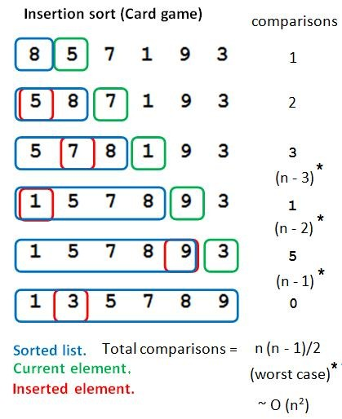

/* Optimal algorithm */
Algorithm where upper bound and lower bound are the same, equals.

/* Merge Sort */
Break down an unsorted array into a bunch of arrays of one element each. Very efficient for large data sets, not so much for smaller data sets. Divide and conquer algorithm. Recursive. Then out of this make arrays of size 2 and size 1.

Compares = is optimal
Space usage = is not optimal, uses extra space vs other sorts like insertion sort
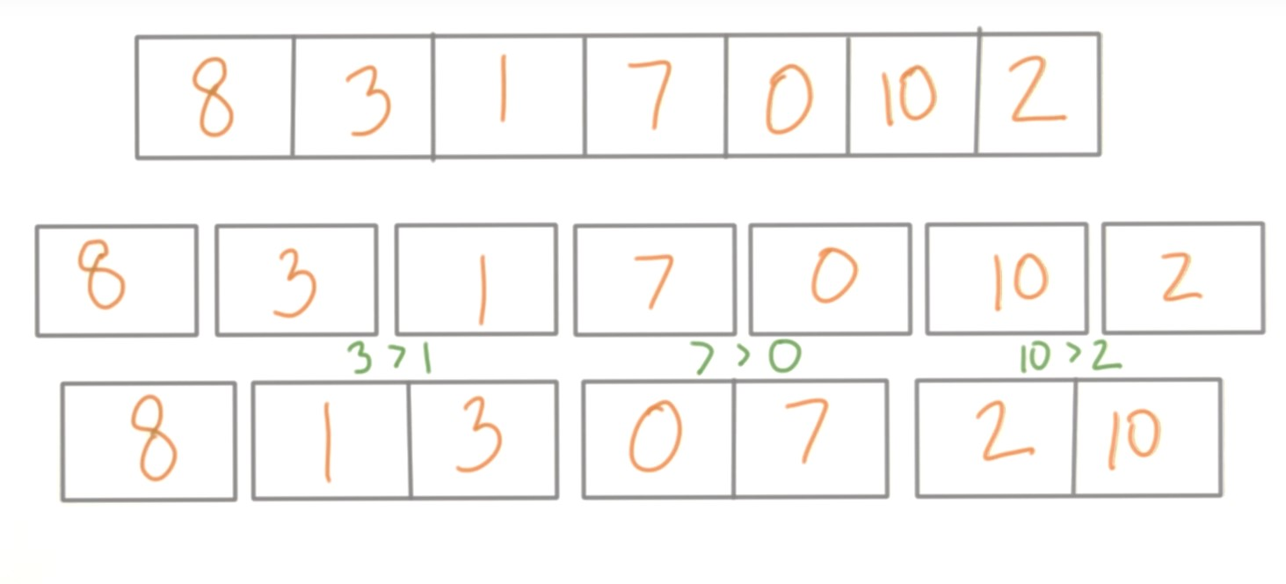
EFFICIENCY = O(n log n) Then combine the first two arrays and the last two arrays and sort them. Then combine the remaining array and sort from the above split array.

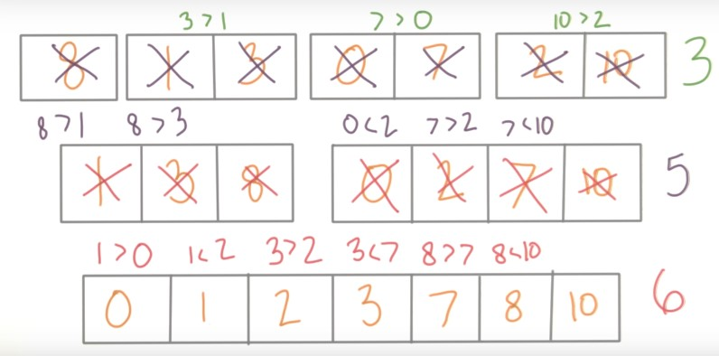

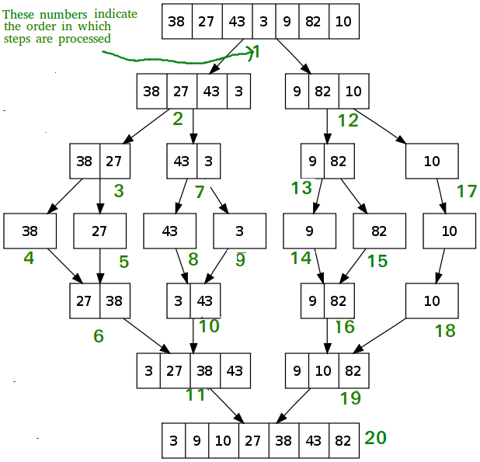

/* Recursion */
A function that calls itself.

//Trees
Organizational relationships are richer than simple before/after. They are hierarchical, above/below with child/parent relations and ancestor/descendant being words to describe nodes.

Each elem has a parent elem and zero or more children elem
The top element is a special node called root with the others being connected below. Root has no parent. In linux the root is called the “root directory” and represented by “/.”

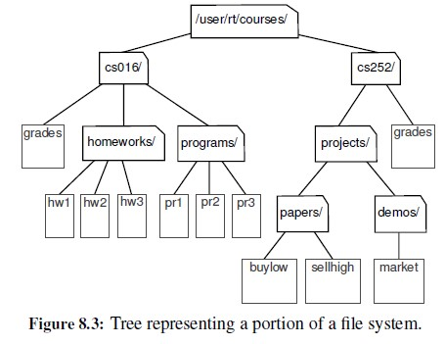

Edge of T = pair of nodes (u, v) so that u is the parent of v or vice versa
Path of T = a seq of nodes such that any two consecutive nodes form an edge. EX: cs252/projects/demos/market
Leaf = the last, bottom most part of the T ex: hw1/hw2/hw3

linked tree O(n)
